***Exhaustive Analysis of Indian agriculture using Power BI***

***Week 1: Assessment***

***Submitted by - shruti***

***Steps :***

***Step1:*** click on the Get data option. Display stating common data source will appear. Click on the Text/CSV option or any other data source where you have stored your file. Once the file open, three options stating load, transform data and cancel appears. Load data only it does not have any defect else click on transform data. Now another window called Power Query Editor where you can transform data.

*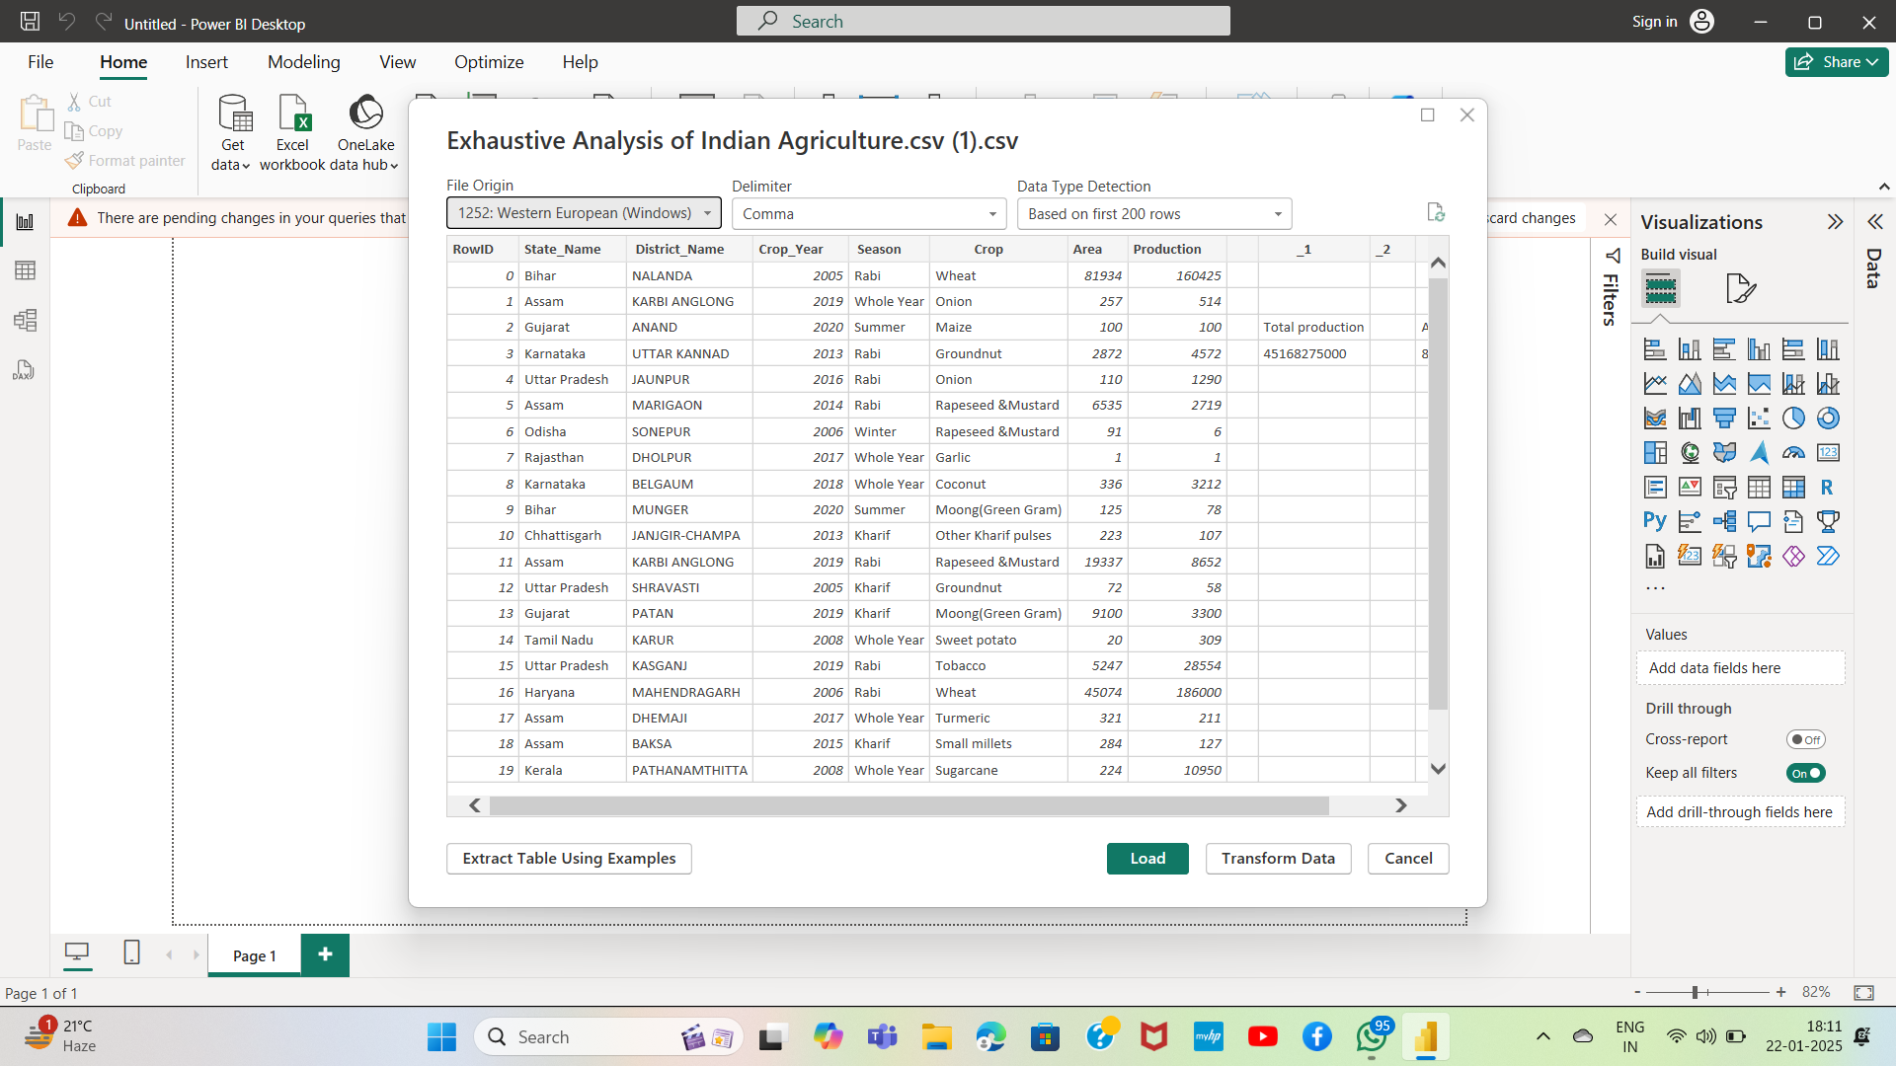step2*: To remove the column

* Click on the column which need to be removed. single click. Click on the remove column in the toolbar. column will be removed. The removed column will appear in the applied steps situated on the lefthand side.

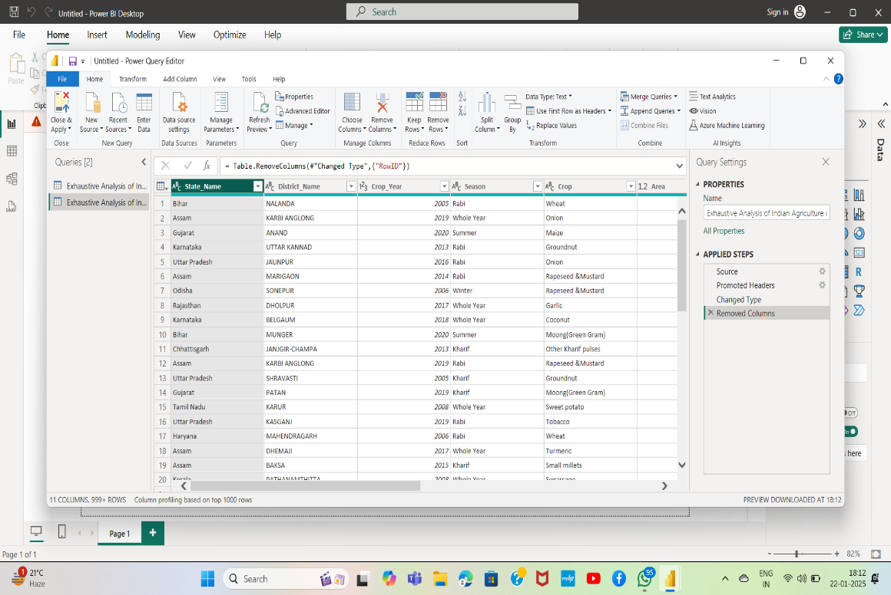

***Step3:***  To check if data has a null value

* Go to view option. Click on the column quality. A small screen will appear showing the function like valid, error and empty.

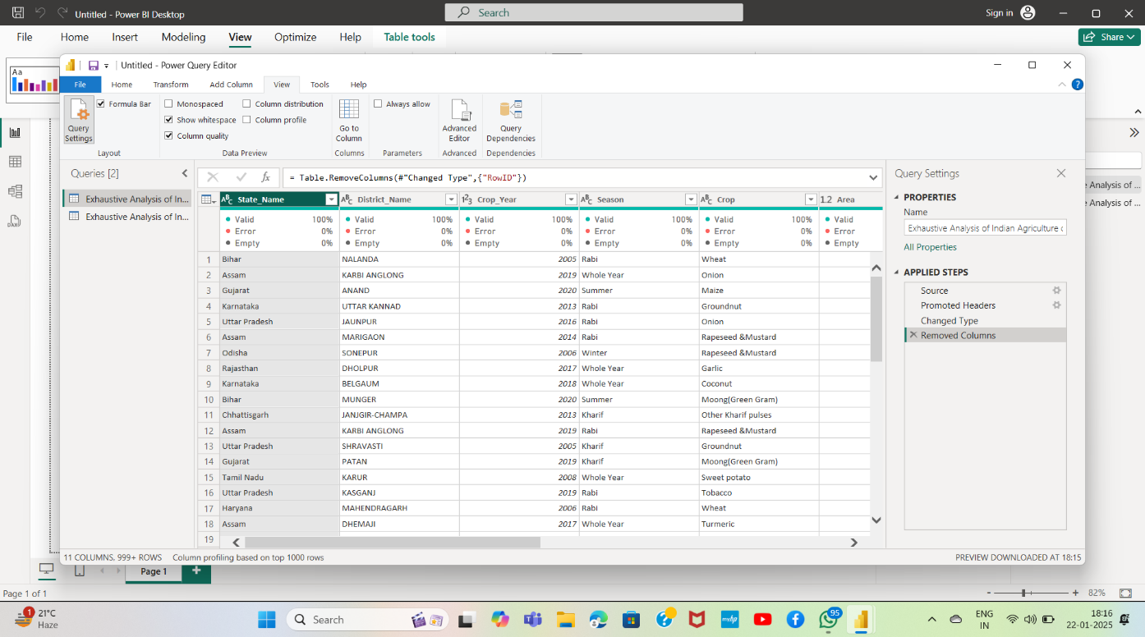

* And now if any blank value is present in your data, then go to remove row option. From there select click on remove blank value. Blank value from the data will be removed and the activity or history will be visible on the lefthand side.

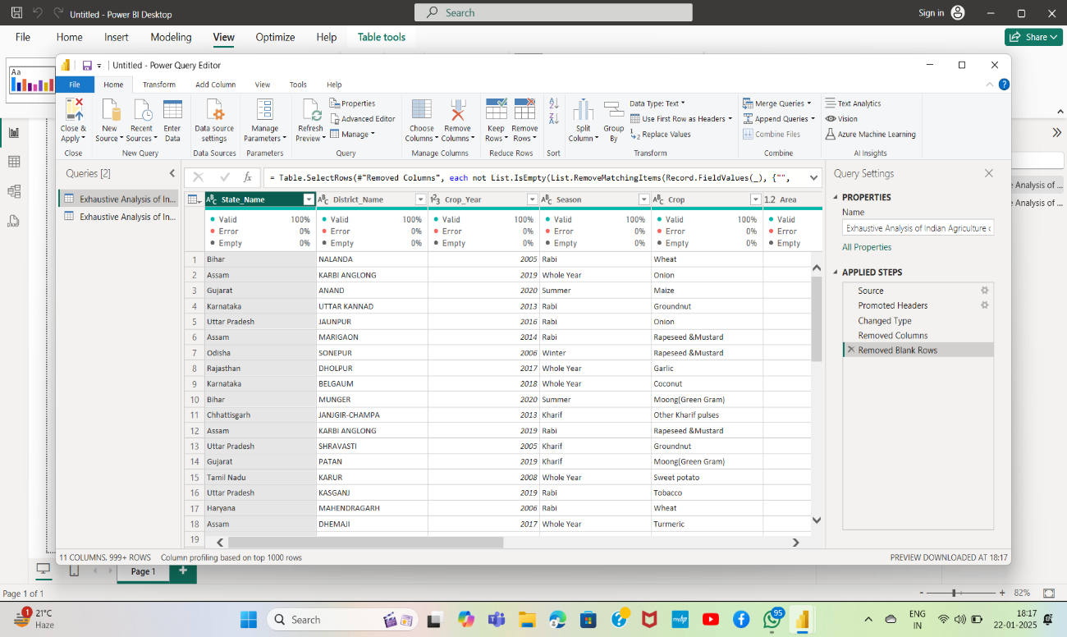

***Step4:***  In order to save the changes made in data, click on the close and apply button. Power BI cannot itself save the changes made in the data.

